ING L3 Hi Voltage Clock Card

1. L3 CCD Requirements
The L3 CCDs require a high voltage clock to be applied to the H2HV pin to induce avalanche multiplication. Avalanche gain commences when the amplitude of this clock reaches approx 35V. The gain is then a steeply rising function of clock amplitude. 50V is the absolute maximum amplitude, beyond which damage can occur to the CCD. The standard SDSU controller can only supply a 10V clock so a new clock driver was built in house and fitted into a spare SDSU slot.

2. Design Description
The card had the same dimensions as a normal SDSU card. It attached to the backplane in the normal way. No signals are obtained from the backplane, only 5V and +/-16V power as well as ground. Signals are fed to and from the card via a 9 way D connector on the front of the card. There is also the option to make the ground connection through this connector instead of the backplane by disconnecting link J10 and making link J7. This was included in the design in case any earthing problems/ground loops were encountered.

2.1. 60V Supply
Two +/-15V DC to DC converters connected in series are used to generate a 60V high voltage bus. No single 60V unit was available.

2.2. Programmable Voltage Regulator
The high voltage bus feeds into a regulator comprising U1,Q1 and Q2. A rising output on op-amp U1 robs base current from the power transistor Q1 and reduces the regulator output voltage. Zener diodes D3 and D4 together dictate the maximum output voltage from this regulator i.e. when the output of U1 is zero.

Two further op-amps (U2 and U3) as well as a voltage reference (U4) are included in the circuit to allow the regulator output to be set by one of the DACs on the SDSU video board. The resistors associated with these op-amps are all low temp co-efficient varieties.
The video board DAC range is +/-5V. When set to zero volts (or when disconnected) the voltage regulator drops to approximately 20V output. When the DAC is set to its maximum positive value the regulator reaches its maximum voltage. The negative part of the DAC range is not utilised and diode D1 ensures that –ve DAC voltages are in fact clipped to zero.

2.3. Output switching circuit
The voltage regulator output is connected to the power rail of the output switching stage via a passive filter consisting of an inductor and an RC smoothing network (L2,R7,C9,C20). The values of R7 and C9 are critical to avoid very unpleasant power on/off transients at the clock output. If C9 is made too large then the inrush current at power on is sufficient to trip the power control board in the SDSU. Inrush current can
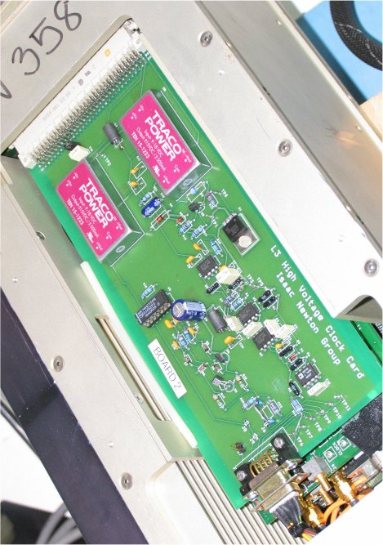
ING HV board mounted in an SDSU II controller
still be a problem if the circuit is powered on with the DAC voltage set to maximum. It is recommended that the SDSU code sets the DAC voltage to zero during the power on sequence, increasing to the higher L3 gain levels a few hundred ms after the controller is fully powered on.

The output drive transistors are biased using Schottky diodes D5,6,7,8. These
transistors are driven through RC shaping networks comprising C12,13,14,15 and R16,17. These values can be trimmed to vary the shape of the edges of the output waveform. The input to this switching circuit is obtained from a spare channel on the standard SDSU clock card and is buffered on board using two 74HCT04 inverters connected in parallel. The push pull output passes through a 100 Ohm resistor to reduce ringing. An optional pulse shaping capacitor can be connected to J6 to smooth the edges of the clock waveform although in practice this was not utilised as the clock edges could be controlled sufficiently using the shaping networks attached to the transistor bases.

3. Tuning the performance

Resistor R14 was chosen with care. It dictates the control range of the DAC i.e. what the output voltage of the clock generator will be when the DAC has its maximum output. It is very important that R14 is not too small or else the transistor Q2 will become saturated when the DAC is below its maximum voltage. This means that when high voltages are demanded the top part of the range will not be fully regulated. R14 was chosen by first setting the DAC to its maximum and then reducing R14 steadily until the Vcb of Q2 reached approx 1V.

The gain of an L3 chip is very critical on the phase of the H2HV clock. In particular, the H2HV clock must be at its maximum value at the moment that clock H1 goes low on the CCD. Small phasing errors between these two clocks can give huge changes in gain. For this reason three extra test points TP9, TP10 and TP11 are included at the edge of the board. These three are undedicated, and simply connect directly to pins on the 9 way edge connector. A further test point TP7 at the board edge is connected to H2HV. These undedicated test points can be used to scope the other clock phases of the CCD i.e. those generated normally by the SDSU clock card. Having all the test points close together like this is much more convenient.

Simon Tulloch Oct 2005

