LIRIS PARK
AND

WYFFOS DETECTOR

LN2 AUTOMATIC FILLING SYSTEM

ARM-TIME MENU OPTION

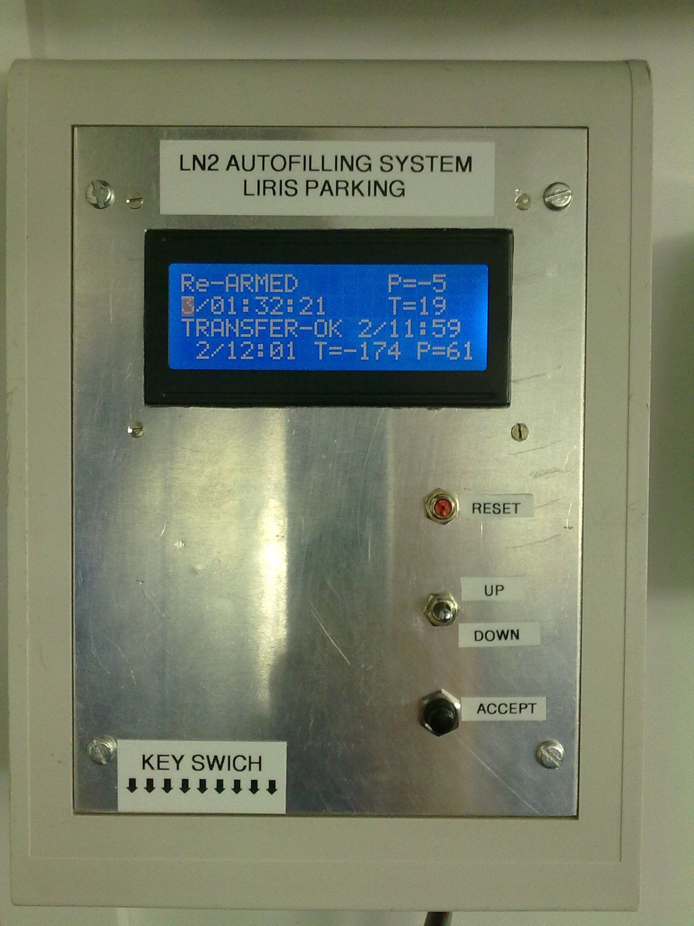

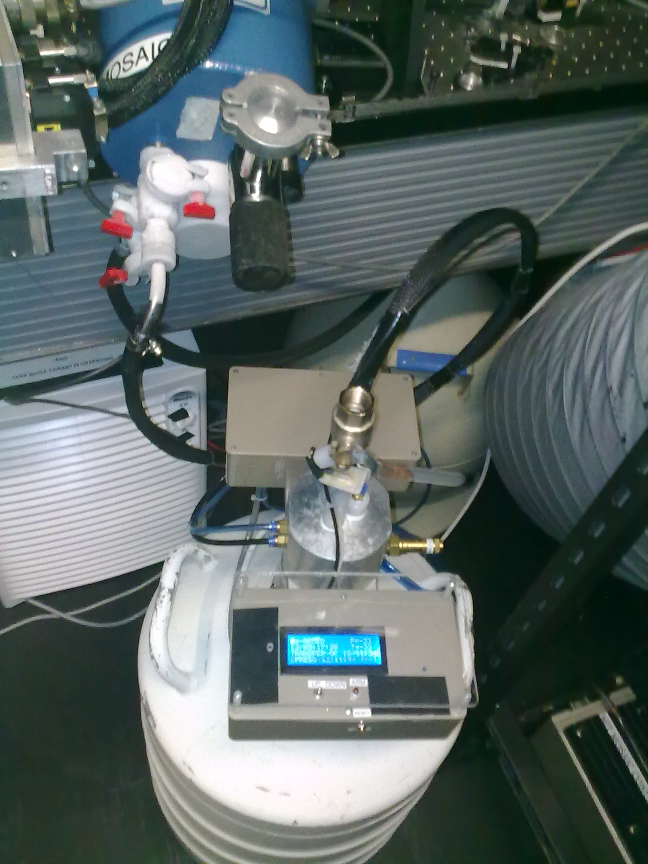
RMR 2012

ARM-TIME ? MENU OPTION

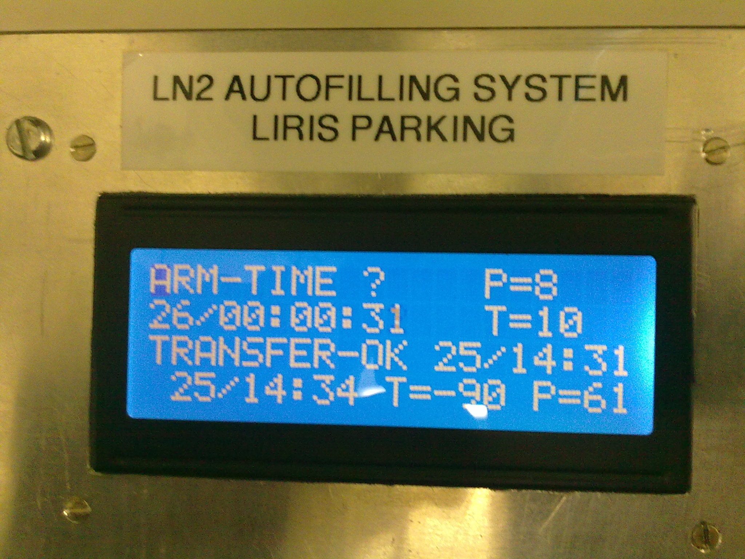

This option in the menu automatic filling system for Liris Park and Wyffos, selects the fill time between 1 and 99 hours.

Normally this set is:
--- Liris Park: 24 h.
--- Wyffos: 8 h.

To change the value:
--- Disarm the filling process. (NOT ARMED)
--- Select Menu. (MENU)
--- Select option ARM-TIME?
--- Set the value in hours.
--- Save the value.
--- Enable the filling process. (Re-ARMED)

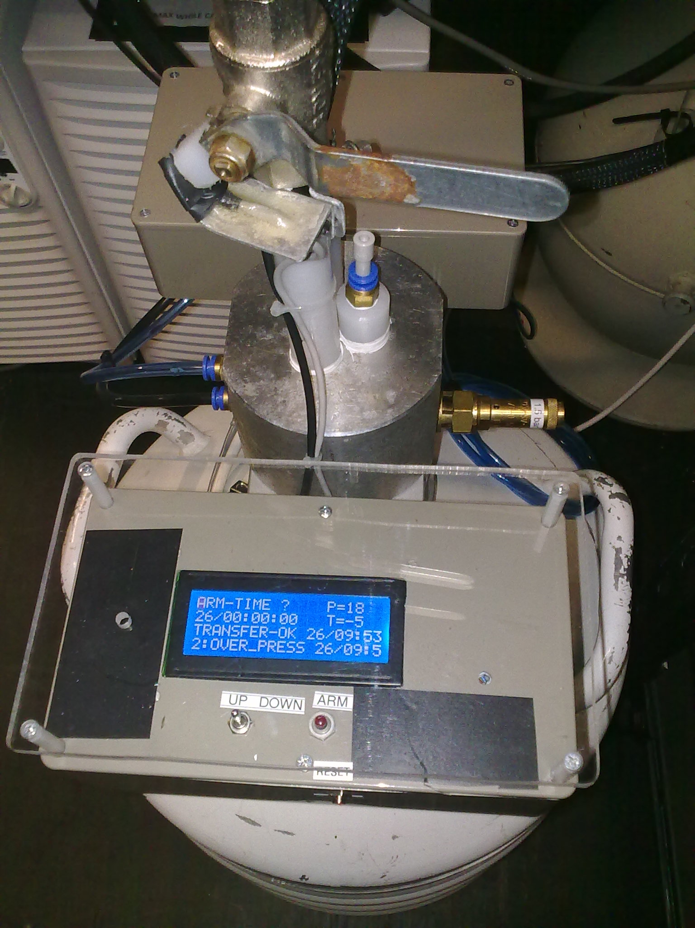

This option is useful if Liris cool head fails.
In this case we must change the Re-ARM value of 8 hours or less to maintain Liris cold.

