

MINUTES

Meeting | ACAM Meeting

Release | Draft/Final  Date: 28th June 2011

Prepared By: | Don Carlos Abrams
Date of Meeting : | 17th April 2011
Owner: | HoE
Client: | Isaac Newton Group of Telescopes
Document Number: | ACAM-MIN-001

Document History

Document Location | The document source can be found at:

Revision History

Version Number | Revision date | Summary of Changes | Changes marked
0.10 | 21/06/11 | Document created | DCA
0.20 | 28/06/11 | Added additional appendices | KMD

Approvals | This document requires the following approvals.

Name | Date of Acceptance | Title | Date of Issue | Version
Don Carlos Abrams | 28/06/11 | Head of Engineering | 23/06/11 | 0.10
Chris Benn |  | Head of Astronomy | 23/06/11 | 0.10
Neil O'Mahony | 13/07/11 | Optical Technician | 23/06/11 | 0.10
Diego Cano | 24/06/11 | Head of T and I | 23/06/11 | 0.10
Kevin Dee | 28/06/11 | Contractor | 23/06/11 | 0.10

Attendance | Attendance will be noted using Email addresses

Complete | Complete | Partial | Apologies
don | dcano
crb | kmd
nom

Agenda | There was no formal agenda for this meeting but the main purpose was to determine the current situation of the scattered light investigations and plan the next activities.

Summary | Don started the meeting by explaining that there were two accepted, potential routes for addressing the ACAM scattered moonlight issue. These were concerned with:  - the design and implementation of appropriate light trap(s) (see Appendix A) to be fitted within the instrument without mechanical disassembly  - the design and implementation of appropriate light trap(s) (see Appendix B) to be fitted in the vicinity of the Nasmyth turret  The evidence supporting these interventions was discussed in detail. Kevin presented mechanical models (see appendices A and B) showing the arrangement of the pertinent components of the telescope and instrument highlighting possible routes that the moonlight could take to reach the detector. Discussions were focussed on:  - Moonlight passing directly through the turret to the CAGB and striking the ACAM fold (see Appendix C).  - Moonlight striking the inner surface of the sky fog baffle or some other component in the turret (see Appendix D) and somehow finding its way to the detector.  Another issue that was discussed was whether moonlight could enter through the holes in the side of the Nasmyth turret structure (see Appendix D). Although this was believed to be unlikely, it wasn’t discounted.  Chris presented a graph showing the intensity of the scattered moonlight as a function of the angular moon distance (see below). He explained that between 0º and 4º and between 19º and 29º the moonlight is obscured by the top-end structures. It was concluded that these data complemented well the models that Kevin presented. 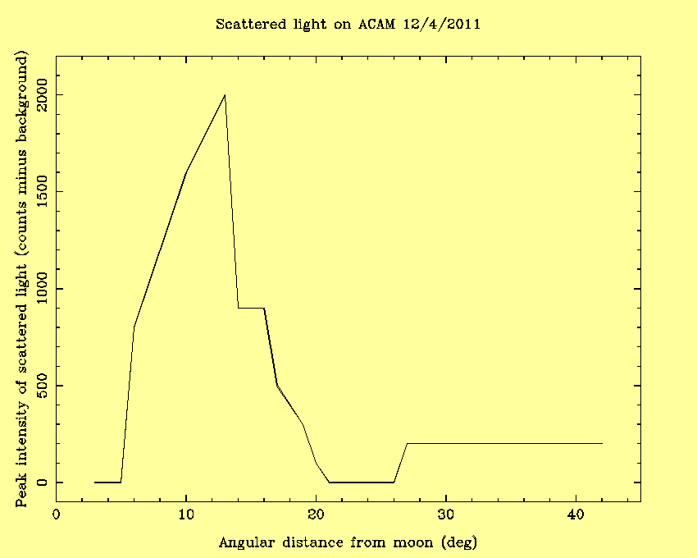  Chris also mentioned that, under certain circumstances, the moonlight could be eradicated if the dome shutters where appropriately positioned. Although this was seen as an effective solution there was some concern (primarily with the duty cycle) should the shutters be used frequently in this manner to address this problem.  It was decided that insufficient information was available to narrow down further the likely route that the moonlight was taking to reach the detector. On the basis of this, additional tests needed to be performed.

Tests | Kevin presented a series of tests and these were discussed:  - Cover secondary mirror and take a series of exposures. This test will be carried out on the 23rd of June.  - Cover the 3 open apertures on the Nasymth turret. If there are changes cover each one in turn. This test will take place on the 11th of July.  - Cover the angled base plate of NAS mirror turntable bracket. With a black card aperture disc which is perpendicular to the on axis light path. This test will take place on the 11th of July.  - At the bottom of the sky fog baffle where it fastens to the Nasymth turret, fit a black card aperture disc.  - Fit a baffle in ACAM between lens 1 and 2 (KMD to provide details for manufacture).  - Remove sky fog baffle. It was decided that this test will not go ahead.

Actions | - Neil will insert a black card cylinder into the instrument and record the impact that this intervention has on the scattered light whilst simulating the moonlight.  - Kevin will design a light trap to be inserted inside ACAM.

AOB | Kevin recommended that when removing the ACAM hubs, only one should be removed at any one time. This avoids the situation where both hubs and the retaining screws are not in place thus reducing the structural integrity of the instrument.

Post-meeting  notes | - Test 1 needs to be carried out with the same top-end configuration that ACAM uses.  - Kevin’s drawing (see Appendix B) is missing the secondary baffle. With this baffle in place, the area of the ACAM fold that can lie within the direct line of sight of the moon is vastly reduced (see Appendix C).

Appendix A. 3D model of ACAM showing possible scattered light path (in red) and illustration of a top hat filter (in green) which could stop scattered light reaching the ACAM detector.

Appendix B – WHT sky fog baffle entrance aperture (710mm diameter 6500 mm from focus) with respect to various moon positions.

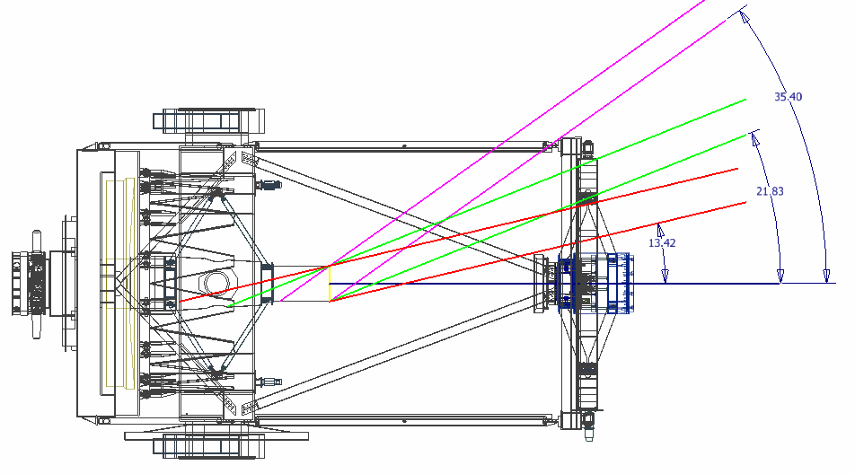

Appendix C – Computer model showing the accessibility to the ACAM fold (white) with and without the secondary baffle in place.

With secondary baffle | Without secondary baffle

Appendix D. Nasmyth Structure

