 | SCATTERED LIGHT AT THE WHT

Project name | ING documentation

Release | Draft/Final  Date:27 Apr. 2011

Written by: | Tibor Agocs, Annemieke Janssen
Edited by: | -
Owner: | Don Carlos Abrams
Client: | Isaac Newton Group of Telescopes
Document Number: | OPT-WHT-002

Document History

Document Location | Printed on 27 April 2011  The document can be found at :  http://www.ing.iac.es/~eng/optics/documents

Revision History | Date of next revision:

Revision date | Version | Summary of Changes | Changes marked
27/04/11 | 0.1 | Document created | Tibor
07-07/11 | 0.2 | Information added | Annemieke

Approvals | This document requires the following approvals.

Name | Title | Date of Approval | Version
Don Carlos Abrams | Head of Engineering
Chris Benn | Head of Astronomy
Diego Cano | Head of T & I

Distribution | This document has been distributed to:

Name | Title | Date of Issue | Version
Don Carlos Abrams | Head of Engineering
Chris Benn | Head of Astronomy
Diego Cano | Head of T & I
Neil O’Mahony | Optical engineer

Purpose | The purpose of this document is to provide information on scattered light issues on the WHT. The document contains the outcome of off-sky and on-sky tests and scattered light analysis that was done with Zemax optical design program.

TABLE OF CONTENTS

LIST OF FIGURES

Figure 1 Scattered light as seen in ACAM when the telescope points between 5 and 30 degrees of the moon.
Figure 2 The following image shows a bright spot at the inner surface of the flip-ring. It is the focused off-axis Moon-light by the primary mirror. Although the light intensity of this spot is quite high, there hasn’t been any evidence that this light-spot is causing the scattered light in ACAM (this is a special case, the angular separation between the telescope and the Moon has to be a certain value).
Figure 3 The following image shows an image that was taken from inside the Nasmyth turret looking towards the secondary mirror. The petals were closed and still the scattered light was visible on the ACAM images. The Moon was off axis and the scattered light from the inside surface of the Nasmyth turret was clearly visible.
Figure 4 The same is shown as on Figure 3, but the zoom scale is different and automatic contrast was applied on the image.
Figure 5 The intensity of the scattered light is highest at 13 degrees. (test done with ACAM)
Figure 6 At 13 degrees the moon appears from behind the secondary mirror and reaches into the sky fog baffle and turret.
figure 7 result of a simulation with Zemax where the whole telescope has been imported. This was for a source at 12 degrees, ten million rays, and all surfaces scattering 80% and reflecting 20% of the incident light. The ray tracing took 1-2 days.
Figure 8 Outcome of Zemax simulation with a light source at 8 degrees. The Nasmyth turret and the barrel between L1 and L2 are modelled as 80% scattering and 20 % direct reflecting. (scale is log5)
Figure 9 Outcome of Zemax simulation with a light source at 12 degrees and the Nasmyth turret and barrel between L1 and L2 modelled, as in Figure 7. This time a 100 million rays are traced (taking a whole weekend of time). The result is not very different from one which is traced with only a million rays.
Figure 10 Zemax simulation with the source at 12 degrees. A completely absorbing baffle has been modelled between L1 and the filter wheels in ACAM.
LIST OF TABLES

Table 1 Images taken by a DSLR camera looking backwards from the folded Cassegrain focus in ACAM. On the left images with dome light, on the right with Moon light are shown; the scales are the same, but the rotational position of the Cass turntable was different for each pair of images (1a-1b, 1c-1d, 1e-1f). 7
Table 2 The following photos were taken from the petals of the primary mirror from inside the Nasmyth turret, looking towards the secondary mirror. The four images are the same but with a different zoom scale. 9
Table 3 The following photos were taken from the petals of the primary mirror, looking towards the secondary mirror. The three images are the same but with a different zoom scale. A flash torch placed in ACAM looking towards the telescope was used to illuminate the Nasmyth turret and the A&G box from inside. 10
Table 4 The following photos were taken from the petals of the primary mirror, looking towards the secondary mirror. The four images are the same but with a different zoom scale. The dome was open and on (? part missing?) 11
Table 5 The inside of the Nasmyth turret is shown on the following images. There are some metal surfaces that should be covered with black tape and two metal brackets that should be removed (they were used for previous tests). 12
Table 6 The following images were taken from the Nasmyth turret looking towards the ACAM CAGB fold mirror. A flash torch placed in ACAM looking towards the telescope was used to illuminate the Nasmyth turret and the A&G box from inside. 6a was taken without the flash of the DSLR camera, 6b-6d with the flash to reveal the mechanical structures (rings, bolts, etc) inside the underlying tube. 13

General overview
A lot of investigation has been done to scattered light in the WHT since this appeared to be a problem in one of the instruments. Observations of ACAM in imaging mode clearly showed scattered light as can be seen in figure 1. It shows the result of an exposure with the moon between about six and thirty degrees from the telescope. The affected area is about 2 or 3 times as bright as when it would not be affected. When the moon is 'above' the telescope, so at higher elevation, the light falls on the upper part of the ccd. This symmetry remains, independent of telescope pointing and moon position. This kind of effects were the starting point for many tests to find out where the light comes into the telescope, and how we can get rid of it.
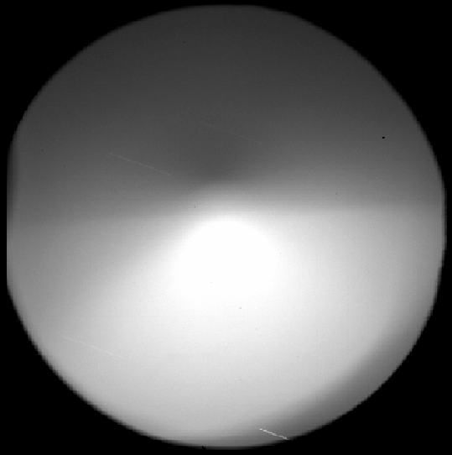
Figure 1 Scattered light as seen in ACAM when the telescope points between 5 and 30 degrees of the moon.

Off-sky and on-sky tests
Different tests have been done by the astronomy group to investigate the problem. They are summarised below:
When ACAM is affected by scattered light, ISIS is probably also affected. This was tested on 20 February 2011 by Ovidiu. Scattered light was visible with ACAM, and the ISIS slit view showed a strong gradient. This means that the problem applies to Cassegrain instruments, and possibly all instruments. It has not been noted before as clearly as with ACAM, because most instruments do not accept that much light coming in off-axis. ACAM is particularly sensitive to scattered light because it has a large opening right in the focal plane. This way it suffers more than other instruments.
The light scatters off something close to the primary mirror, and not off the secondary mirror (or the construction around it). This was tested on 17 and 19 January 2011 (Marie, Lilian, Ovidiu) with the moon close to zenith. Scattered light was visible on ACAM images while the dome was opened up completely. Then the dome shutter was closed in small steps. One could see clearly from inside the dome which parts of the telescope were lit by the moon and which not. The scattered light disappeared from the images while the secondary mirror was still bathing in moon-light and the primary was completely covered from moon-light .
However it is probably not the primary mirror itself that reflects the moon-light. When the mirror petals are closed, the scattered light is still visible and has the same pattern as before. (20 February 2011, Ovidiu). The fact that the scattered light does not disappear when closing the mirror petals means that the moon-light has to scatter off something else than the primary mirror. This was confirmed in a similar test on June 23th 2011, the same test was repeated but this time without the secondary mirror on the telescope. So light does not (or little) scatter off the secondary mirror.

The scattered light can be a problem with any kind of bright source between six and thirty degrees of the telescope, like the sky during twilight. In that case the flat fields made during twilight are not really flat, and they will thus not do a good job. This seems to be the case indeed, as was tested 13 February 2011 by Annemieke. This is a problem when observers want to do accurate photometry. It also means that blocking out the moon-light with for example a 'moon shield' would not solve everything.
All the scattered light in ACAM comes through the centre of the focal-plane. (17 January 2011, Ovidiu, Lilian, Marie) When black-card masks with central circular apertures are inserted in the ACAM focal-plane slide, the intensity of the scattered light on the CCD shows no dependence on aperture diameter, for diameters between 20 and 100 mm. This implies that all the scattered light enters through the central 20-mm diameter of the focal plane. When a card without any hole is placed in the focal-plane slide, the scattered light vanishes.
A different approach was tried at 12 April 2011. (Neil, Chris, Tibor, Kevin, Annemieke) During the day a photo camera was placed in ACAM which took pictures 'backwards', so of the telescope itself. The same was done during the night while the moon was up. Table 1 shows the results. In 1a one can see the elliptical mirror with a black taped ring around it. The six dark squares are screws or something similar into the M1 extension box (at least, that is our guess). The two dark pieces are metal brackets that should be removed, see also table 6. The bright object at the same height as the metal brackets is probably the Nasmyth mirror. The photos on the right show scattered light, but it is not completely clear where it scatters, it can be the sky fog baffle or something around the secondary mirror.
Table 1 Images taken by a DSLR camera looking backwards from the folded Cassegrain focus in ACAM. On the left images with dome light, on the right with Moon light are shown; the scales are the same, but the rotational position of the Cass turntable was different for each pair of images (1a-1b, 1c-1d, 1e-1f).
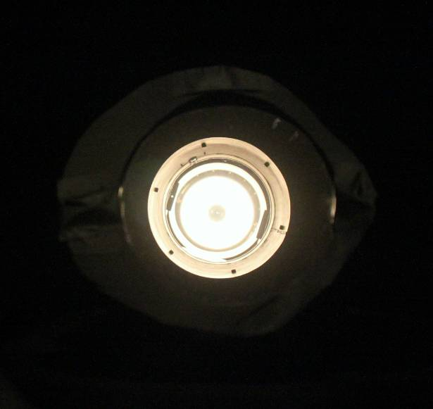  1a | 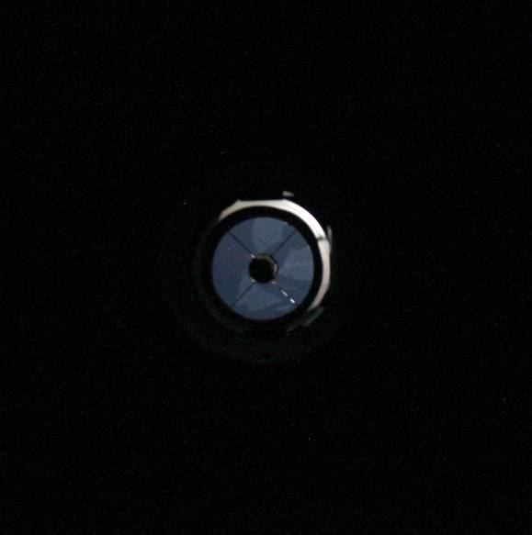  1b
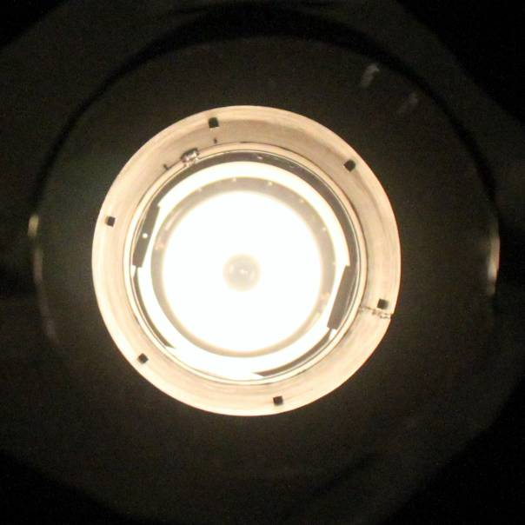  1c | 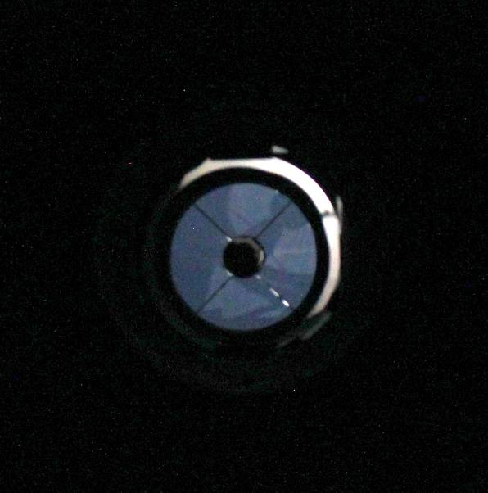  1d
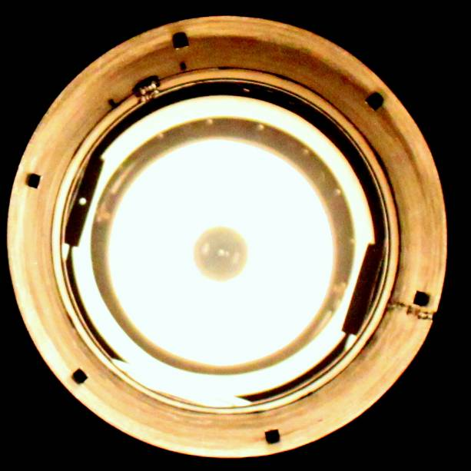  1e | 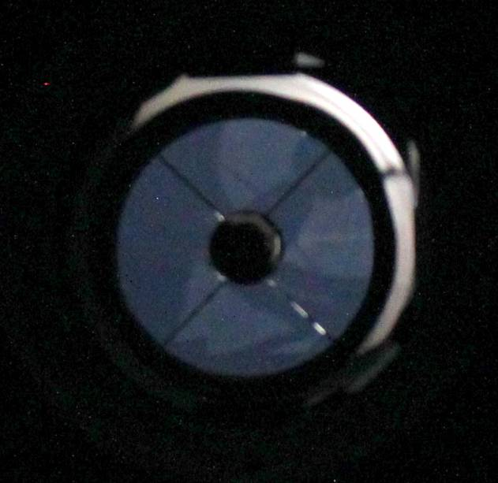  1f

Table 2 The following photos were taken from the petals of the primary mirror from inside the Nasmyth turret, looking towards the secondary mirror. The four images are the same but with a different zoom scale.
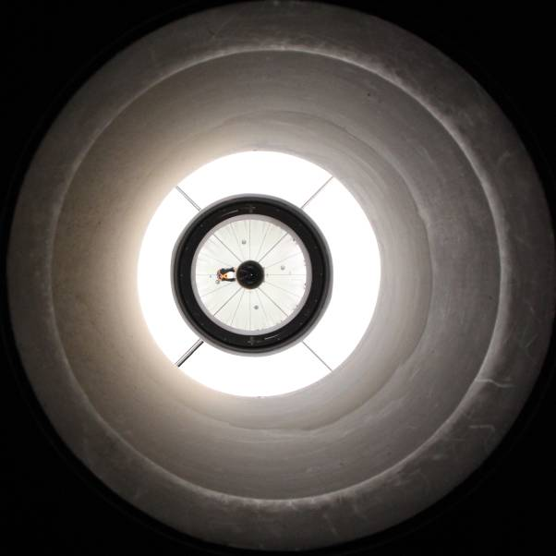  2a | 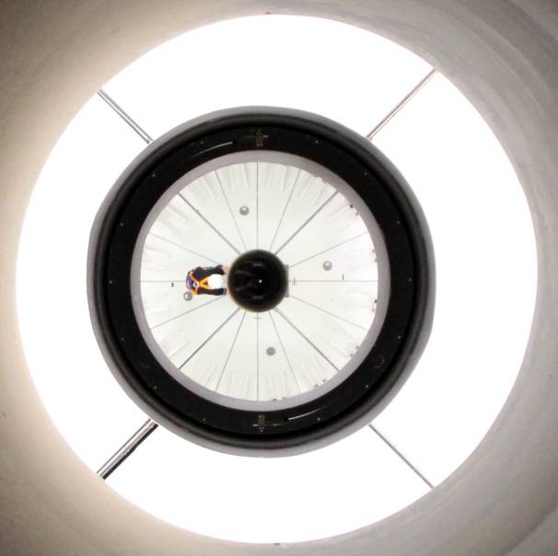  2b
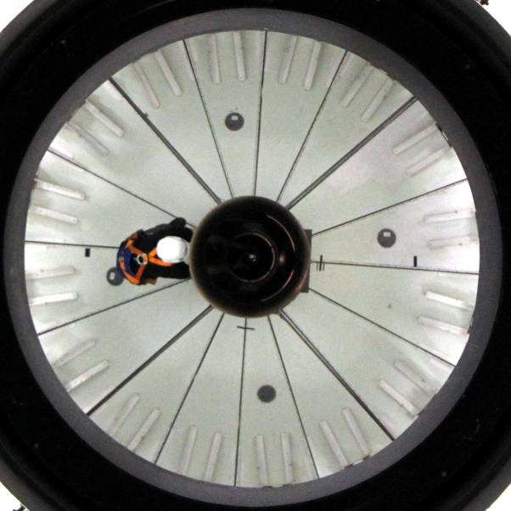  2c | 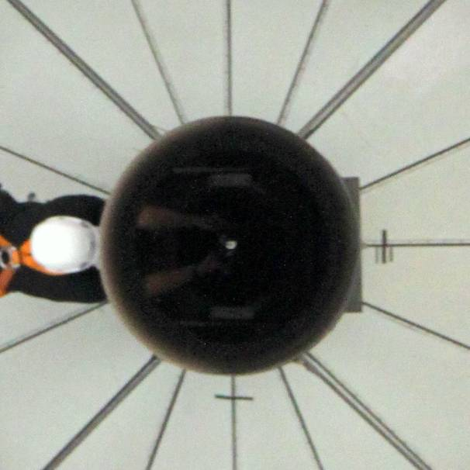  2d

Table 3 The following photos were taken from the petals of the primary mirror, looking towards the secondary mirror. The three images are the same but with a different zoom scale. A flash torch placed in ACAM looking towards the telescope was used to illuminate the Nasmyth turret and the A&G box from inside.
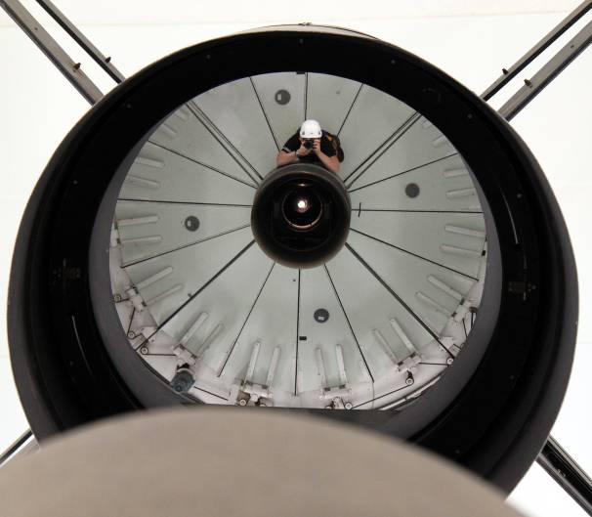  3a | 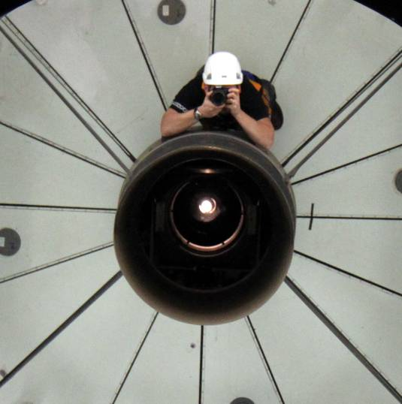  3b
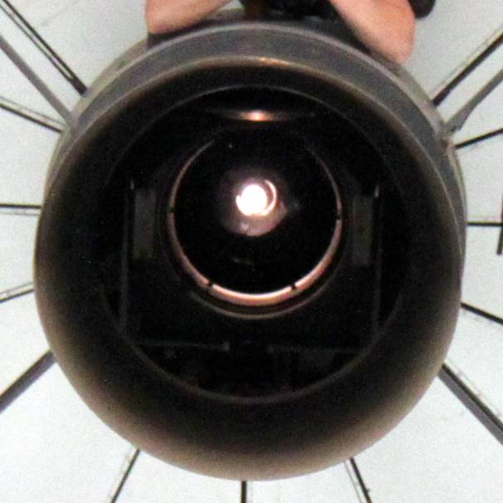
3c

Table 4 The following photos were taken from the petals of the primary mirror, looking towards the secondary mirror. The four images are the same but with a different zoom scale. The dome was open and on (? part missing?)
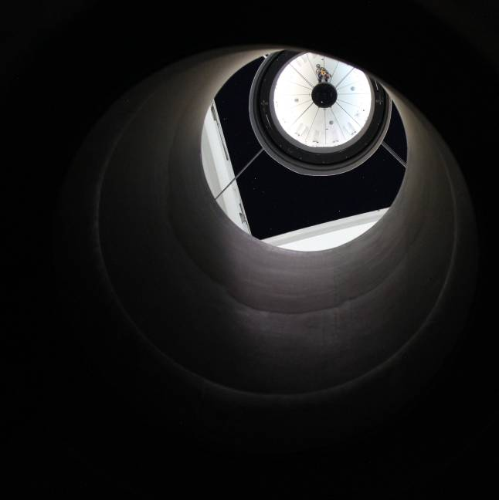  4a | 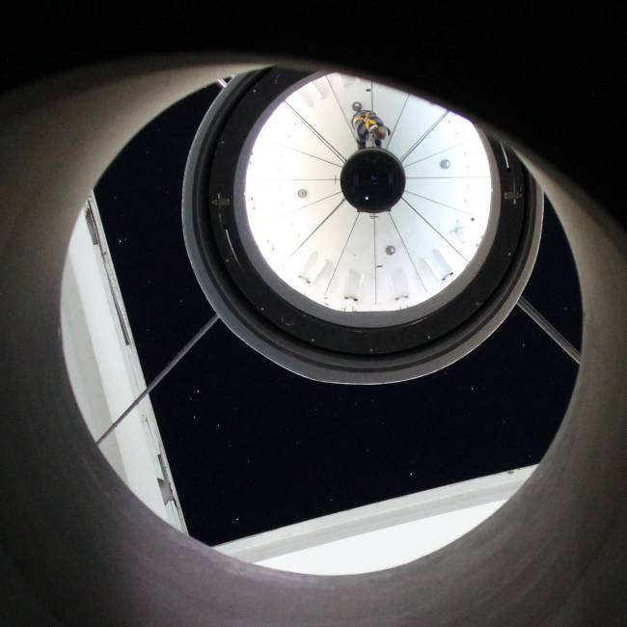  4b
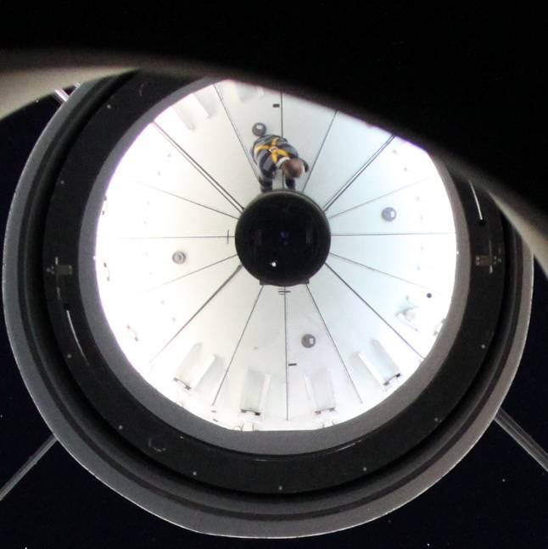  4c | 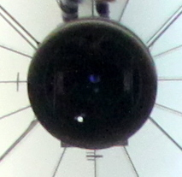  4d

Table 5 The inside of the Nasmyth turret is shown on the following images. There are some metal surfaces that should be covered with black tape and two metal brackets that should be removed (they were used for previous tests).
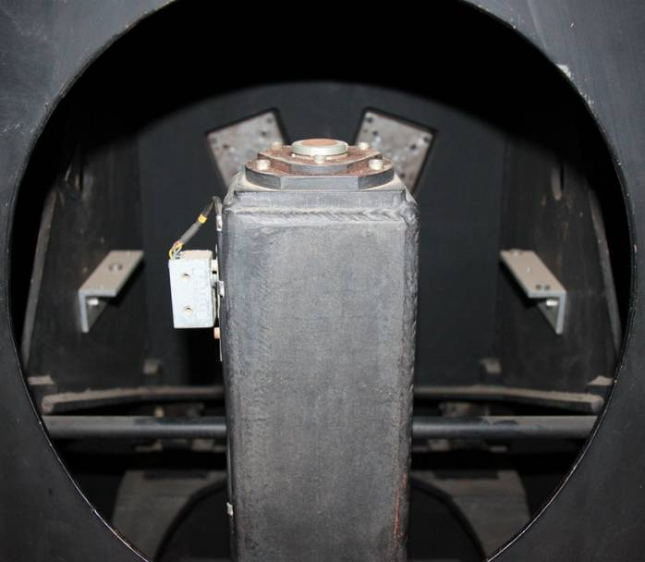  5a | 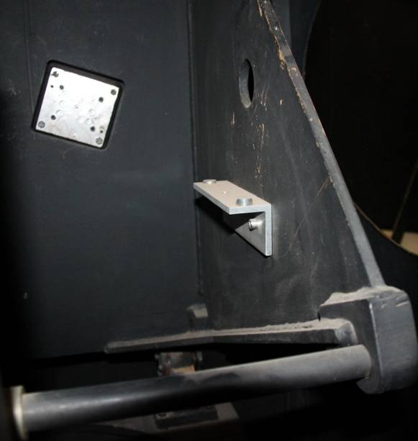  5b

Table 6 The following images were taken from the Nasmyth turret looking towards the ACAM CAGB fold mirror. A flash torch placed in ACAM looking towards the telescope was used to illuminate the Nasmyth turret and the A&G box from inside. 6a was taken without the flash of the DSLR camera, 6b-6d with the flash to reveal the mechanical structures (rings, bolts, etc) inside the underlying tube.
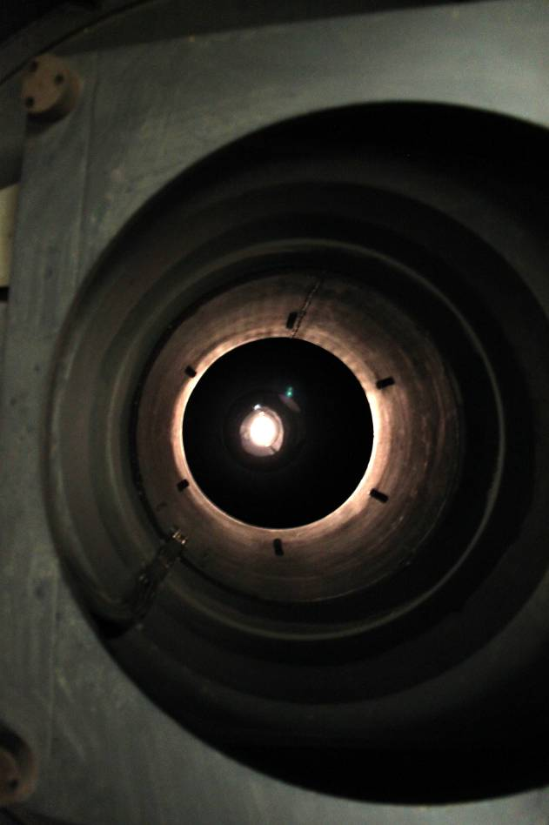  6a | 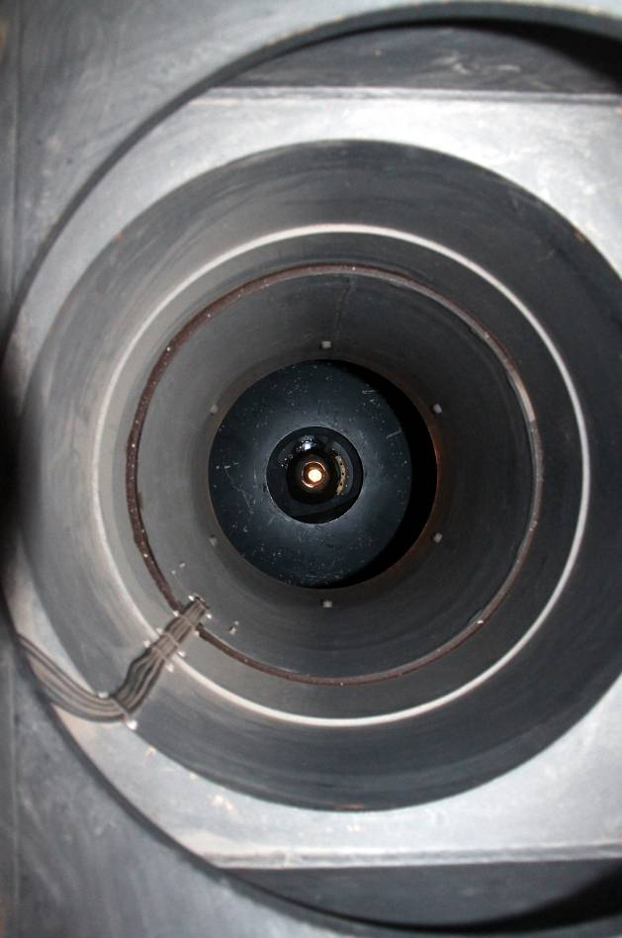  6b
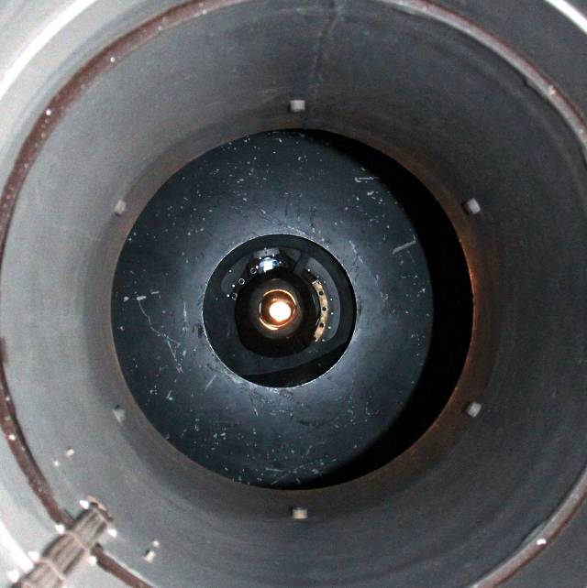  6c | 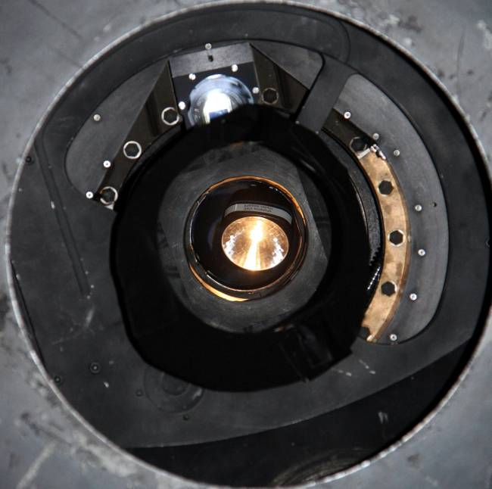  6d

Figure 2 The following image shows a bright spot at the inner surface of the flip-ring. It is the focused off-axis Moon-light by the primary mirror. Although the light intensity of this spot is quite high, there hasn’t been any evidence that this light-spot is causing the scattered light in ACAM (this is a special case, the angular separation between the telescope and the Moon has to be a certain value).
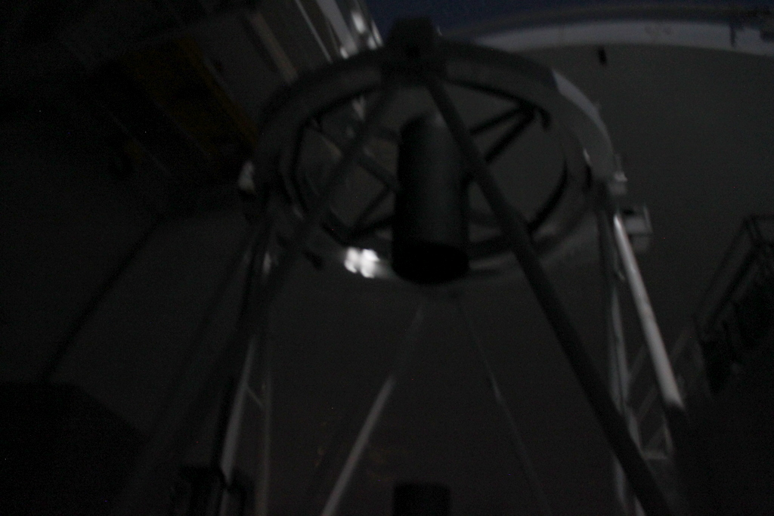

Figure 3 The following image shows an image that was taken from inside the Nasmyth turret looking towards the secondary mirror. The petals were closed and still the scattered light was visible on the ACAM images. The Moon was off axis and the scattered light from the inside surface of the Nasmyth turret was clearly visible.
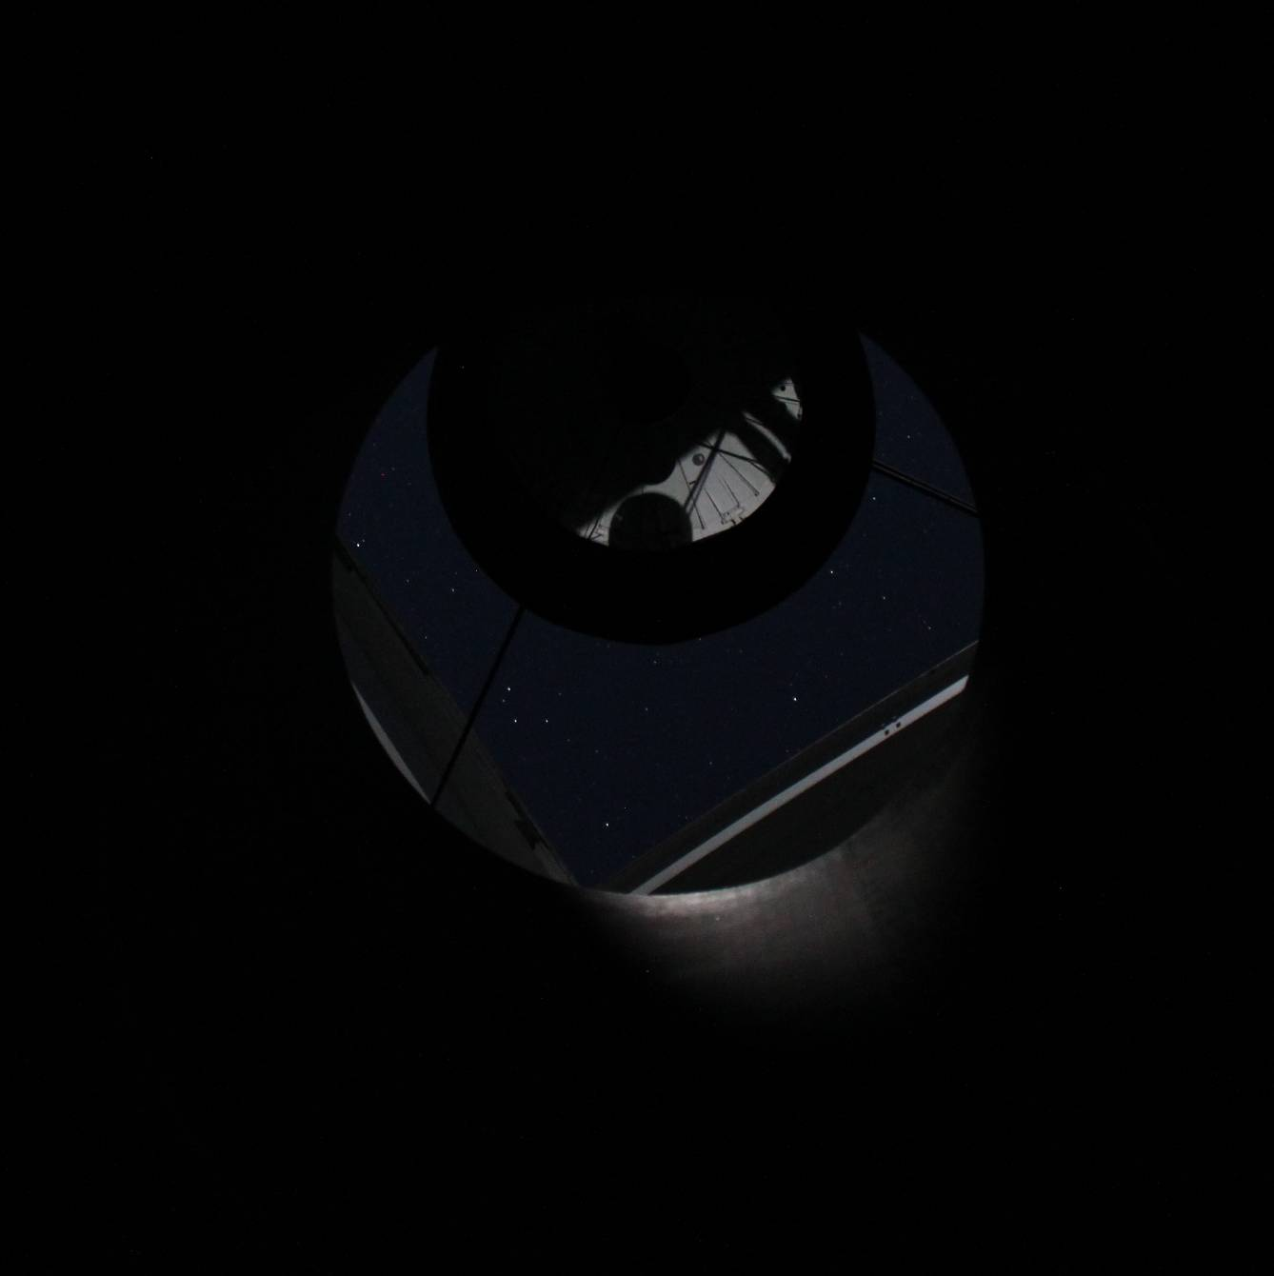

Figure 4 The same is shown as on Figure 3, but the zoom scale is different and automatic contrast was applied on the image.
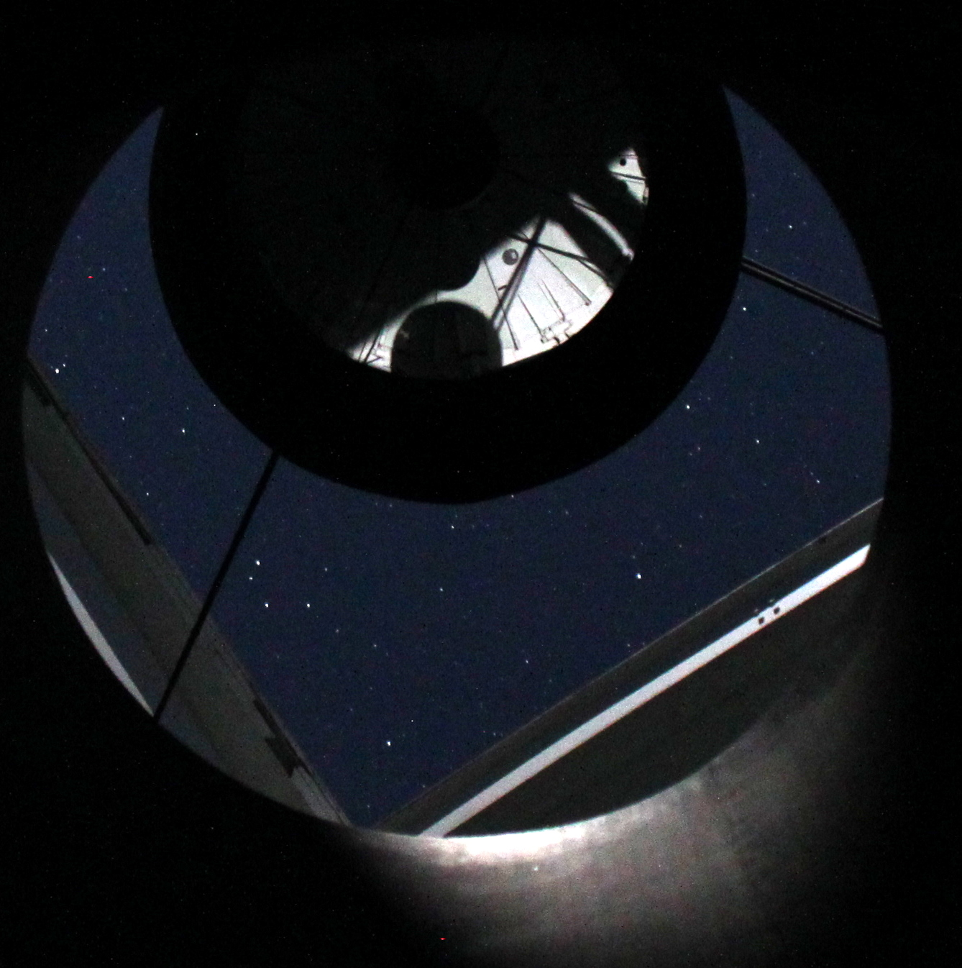
During the same night in which the pictures were taken two on-sky tests have been done. The first one was to make sure that the light does not come through the Nasmyth holes. First an exposure is taken with the moon shining directly at the hole, then the telescope is turned by 180 degrees so that the moon shines on the covered hole. There was no difference in the amount of scattered light on an ACAM exposure, so the light did not enter the telescope through the Nasmyth hole.
Then the intensity of the scattered light was measured as a function of moon angle. The result is given in figure 5. At 4 degrees the scattered light starts to appear in the images, at 13 degrees the intensity is highest. There is a dip between about 21 and 26 degrees. After this the light reappears but at this level it is not problematic any more.
This plot, in combination with figure 6, convinced us that moon-light scatters off the telescope baffle. At 13 degrees the moon is not blocked by the secondary mirror any more, and hits the sky fog baffle and turret over the whole length. At 22 degrees the moon starts to disappear behind the top end ring, and between 25 and 30 degrees it should be blocked completely. This is a few degrees larger than one would conclude from the observations in figure 5, possibly the moon angle in this plot is not very accurate because the moon was moving during the test, or something else must have blocked some light at 21 degrees.
If the moon-light indeed gets into the sky fog baffle directly, the most direct approach is to make a light trap baffle in it. We tested this with a quickly improvised baffle next day. It consisted of flexible tubes that were taped into a cylinder that just fits in the sky fog baffle. The cylinder was 1130 mm long, the tubes had a diameter of 40 mm and were cut in half to get flat surfaces. Then these half tubes were taped into the cylinder with a distance of 60 mm between them. With this ratio 40:60 all light that falls in the baffle with an incident angle below 34 degrees will be trapped. However that night the scattered light on the ACAM images was worse than the night before. There are different explanations for this: the moon was waxing, the baffle was too short to have a significant effect, and the tubes might have reflected light back on to the secondary mirror. Moreover the tubes were so big that they vignetted the light for the autoguider so it would not have been a good permanent solution. (The autoguider observes from 7.3 till 12.1 arc minute (radius) , as concluded from our website: http://www.ing.iac.es/Astronomy/observing/manuals/html_manuals/infra/WHT-CAGB.html . At 10.2 arc minute the sky fog baffle starts to vignette the beam by a few percent.)
Now we know the path taken by the moon light, the scattered light can be created by shining a torch into the sky fog baffle. This was tried and gave similar images as during a night with moon. It is of great help when we want to test something during the day.

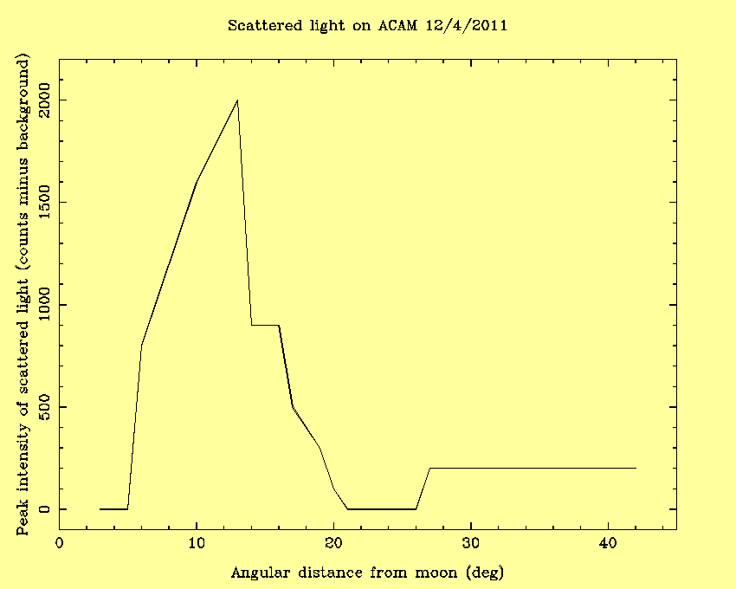
Figure 5 The intensity of the scattered light is highest at 13 degrees. (test done with ACAM)
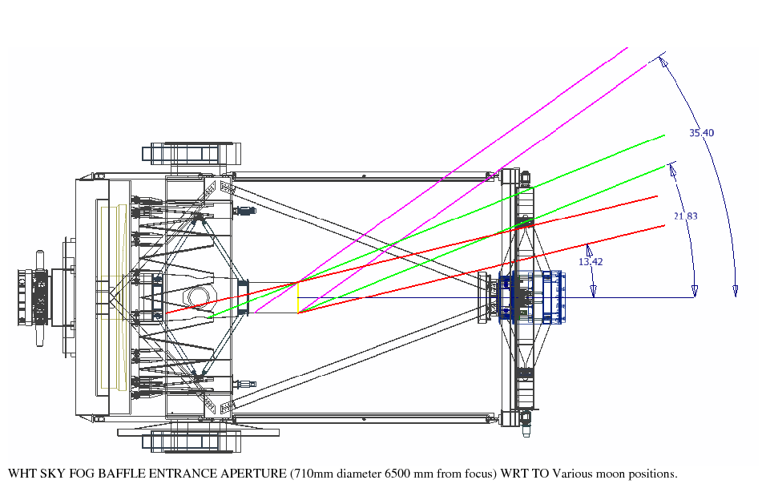
Figure 6 At 13 degrees the moon appears from behind the secondary mirror and reaches into the sky fog baffle and turret.

Zemax simulations
To be able to simulate the scattered light in Zemax, it is necessary to have a good model of the telescope. The mechanical models of the WHT from Kevin can be imported in Zemax, but ray tracing takes a very long time. Because all details are modelled it can take hours to days to run a simulation, and the result is not what we see on the ccd:
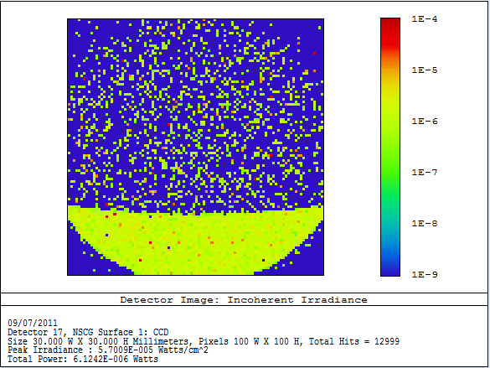
figure 7 result of a simulation with Zemax where the whole telescope has been imported. This was for a source at 12 degrees, five million rays, and all surfaces scattering 80% and reflecting 20% of the incident light. The ray tracing took 1-2 days.
ACAM is not included in the model but the lenses and detector can be added separately to get a total effect of telescope+ACAM. Tibor made a simplified telescope model with a cylinder as the telescope baffle + turret. The ray tracing goes much faster but the pattern we see looks different from before, see figure 8 and 9.

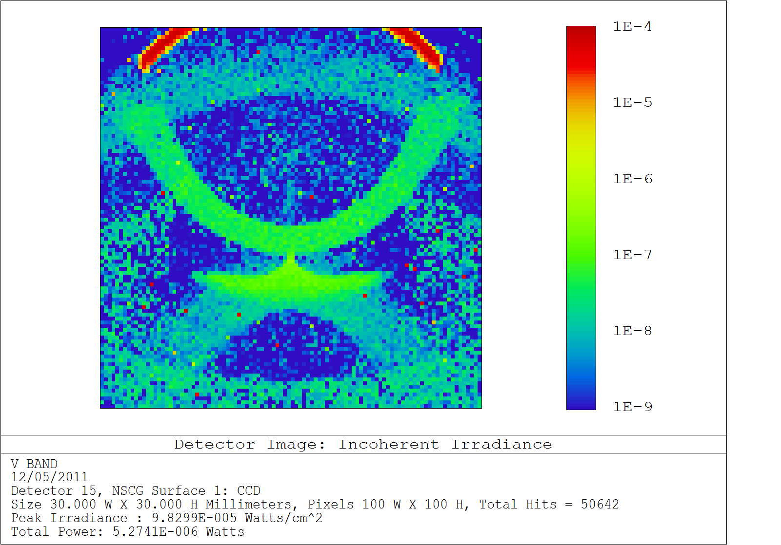
Figure 8 Outcome of Zemax simulation with a light source at 8 degrees. The Nasmyth turret and the barrel between L1 and L2 are modelled as 80% scattering and 20 % direct reflecting.
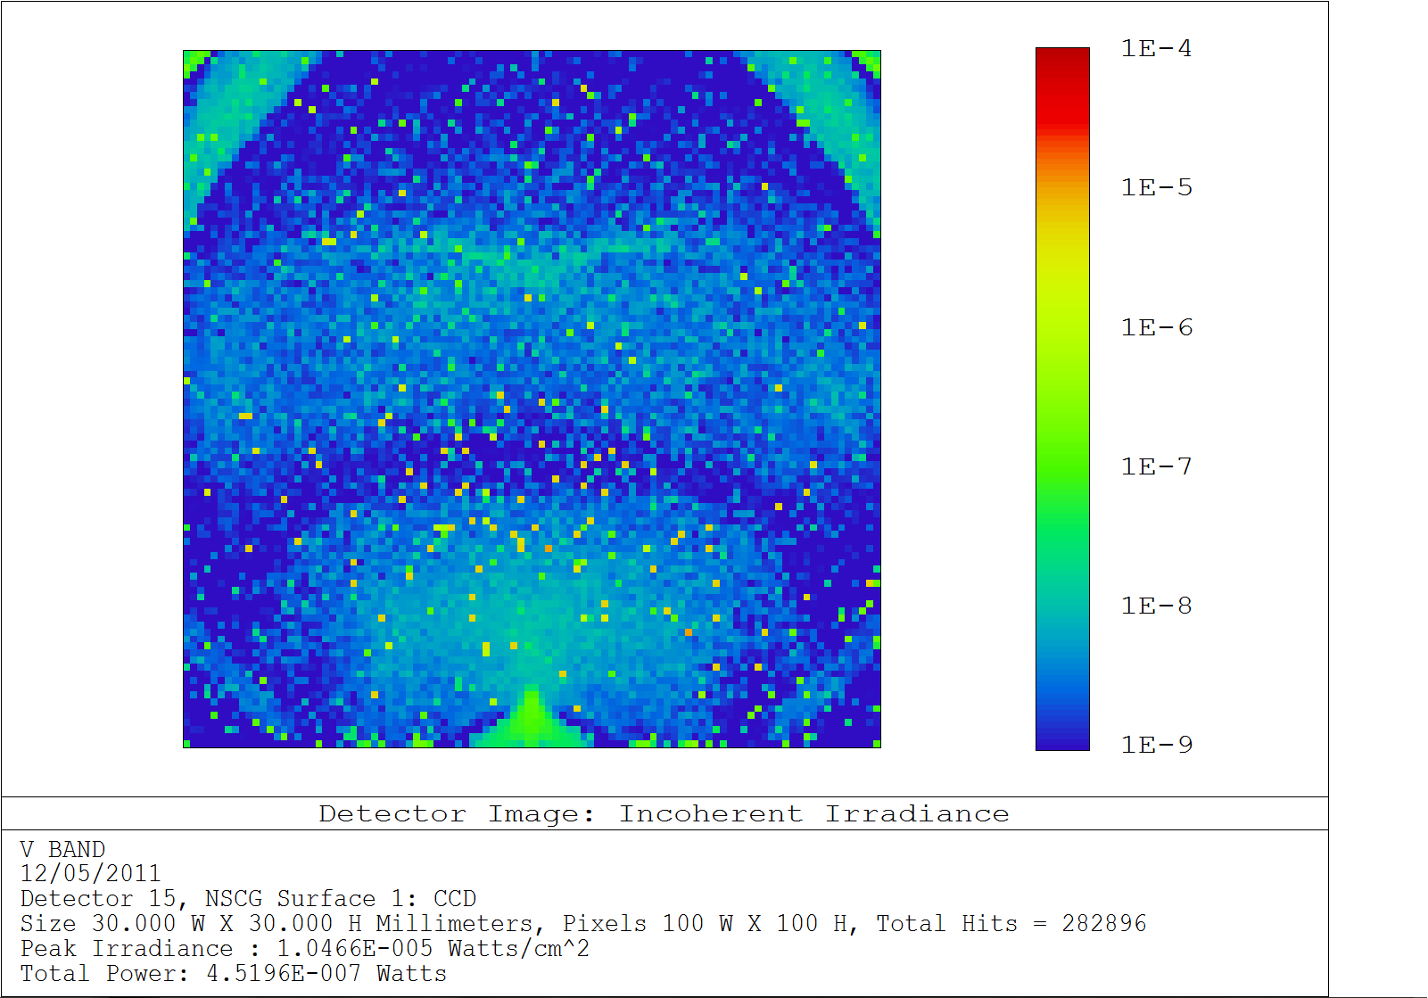
Figure 9 Outcome of Zemax simulation with a light source at 12 degrees and the Nasmyth turret and barrel between L1 and L2 modelled, as in Figure 7. This time a 100 million rays are traced (taking a whole weekend of time). The result is not very different from one which is traced with only a million rays.
Say that we want to know the result of a perfectly absorbing baffle in ACAM, between L1 and the filter wheels (here is space for a baffle). The simplified model suggests that we can get rid of much of the light, but not all (see figure 10). Since we do not know how accurate the models are, the amount of light we will reject with an ACAM baffle can not be predicted accurately.
It is possible that zemax can model the scattered light correctly, but there are many variables and we have no idea where to start. We do not know for example which fraction of the light is scattered and reflected from all different surfaces in the telescope. The whole telescope is now imported as one piece, so it is not possible to assign different properties to different parts. The A&G box is not included in the model, nor is ACAM as a whole instrument (only the optics, L1 barrel and a cylinder between L1 and the filter wheels). Moreover there are many different ways to model scattered light and you need to be a bit of an expert in this field to do it efficiently which we unfortunately are not.
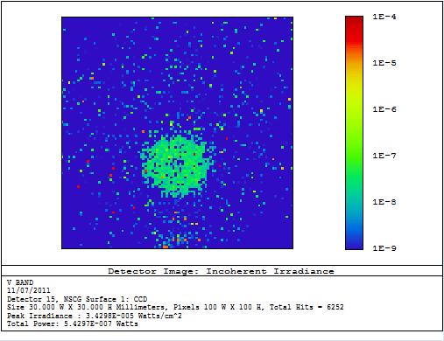
Figure 10 Zemax simulation with the source at 12 degrees. A completely absorbing baffle has been modelled between L1 and the filter wheels in ACAM.

Possible Solutions
Now we have an idea of where the light enters the telescope, we can think about a solution. There are two obvious solutions: place a light trap baffle in ACAM, or place one in the sky fog baffle / turret. ACAM has space for a baffle between the first lens and the filter wheel, this space was 'reserved' for a baffle but was never placed there. (correct?) It is currently a cylinder with a rough, black painted surface with a length of 297 mm and a diameter of 160 mm. It is relatively easy to reach this space through the filter wheel box. However the opening between the cylinder and the filter wheel box is slightly smaller than 160 mm (how small?), and the filter wheel box is only 100 mm wide (chris mentioned 90 but I measured 100. what is it?), so anything we want to put in the cylinder has to be cut in three or more pieces or it has to be flexible. (Or it must be small enough to be put in ACAM in one piece.) Moreover if we want to attach it with screws we have to ask Kevin to design a mount or holder because the screw holes are unreachable. The other option is baffling the sky fog baffle and maybe the turret. As one can see in figure 6, the baffle has to reach from the top of the sky fog baffle till the primary mirror to reject all the light with an incident angle of 13 degrees. It is difficult to reach all the way into the turret, so we would first try to solve the problem inside the sky fog baffle. ( for example by placing a ring at the base of the sky fog baffle, currently under investigation.)
There is a model of the WHT on the ZEMAX-SLO computer, made in INVENTOR. On the same computer we have an 'inventor-viewer' but this does not give sizes of telescope parts. It is possible to download a trial version of Inventor for one month. This would allow us to get accurate sizes of all parts in the WHT, which can be very useful if we have to implement something in the telescope.
When finally decided where to place a baffle, the next question is what kind of baffle. At the moment we are investigating the possibility of black high-absorbing materials that can be glued into an instrument/telescope. There is a company that claims to have materials absorbing 99.99% of the incident light (for angles up to 45 degrees, in the visible), and it might be a good alternative to a 'standard' baffle in which a series of black painted rings are placed in a cylinder. A first price indication we got from Acktar is €250,- per square metre for the 'Metal Velvet' (the material with least scatter). The surface area in ACAM is about 0.15 m^{^2} and the sky fog baffle is about 2.5 m^{^2}. We do not know yet whether these materials are as durable as conventional baffles. Another difficulty is that it is not known how much light is currently absorbed in the sky fog baffle and ACAM. The sky fog baffle seems a poor absorber, so possibly a big improvement could be made with a simple material (a new black coating for example).

Conclusions
The scattered light is caused by moon-light entering the telescope through the sky fog baffle, without scattering off other parts of the telescope first. This was concluded from: 1) the scattered light is present even when the mirror covers are closed and the secondary mirror is not in use. 2) The light can be seen entering the baffle from one of the Nasmyth holes. 3) The same effect arises when shining a torch into the baffle. 4) The intensity of the scattered light is as predicted by the geometry of the telescope (which also predicts light entering through the baffle).
The way to get rid of this light is placing a light trap baffle in the sky fog baffle of the telescope, and/or in ACAM. If it is sufficient to baffle ACAM only, this would be the easiest and cheapest solution. Before starting with designing or buying anything we would have liked to model the effect in Zemax, but Zemax does not exactly predict what is seen on the CCD so we cannot be sure that the scattered light has been modelled correctly.

References

