Weave Autoguider System Overview

Weave is different from all other ING instruments in that it has two autoguiders, one for the MOS plates and another for the LIFU.
Weave uses a modified version of the standard ING autoguider. The standard system uses a single DAS machine + SDSU controller for each camera head. The Weave system uses a single DAS machine + SDSU controller to drive both the MOS and LIFU heads. This reduces both weight and heat at prime.

MOS AG Camera
DAS Machine

Weave AG SDSU Controller
Camera Peltier PSU

LIFU AG Camera

SDSU PSU

System Layout
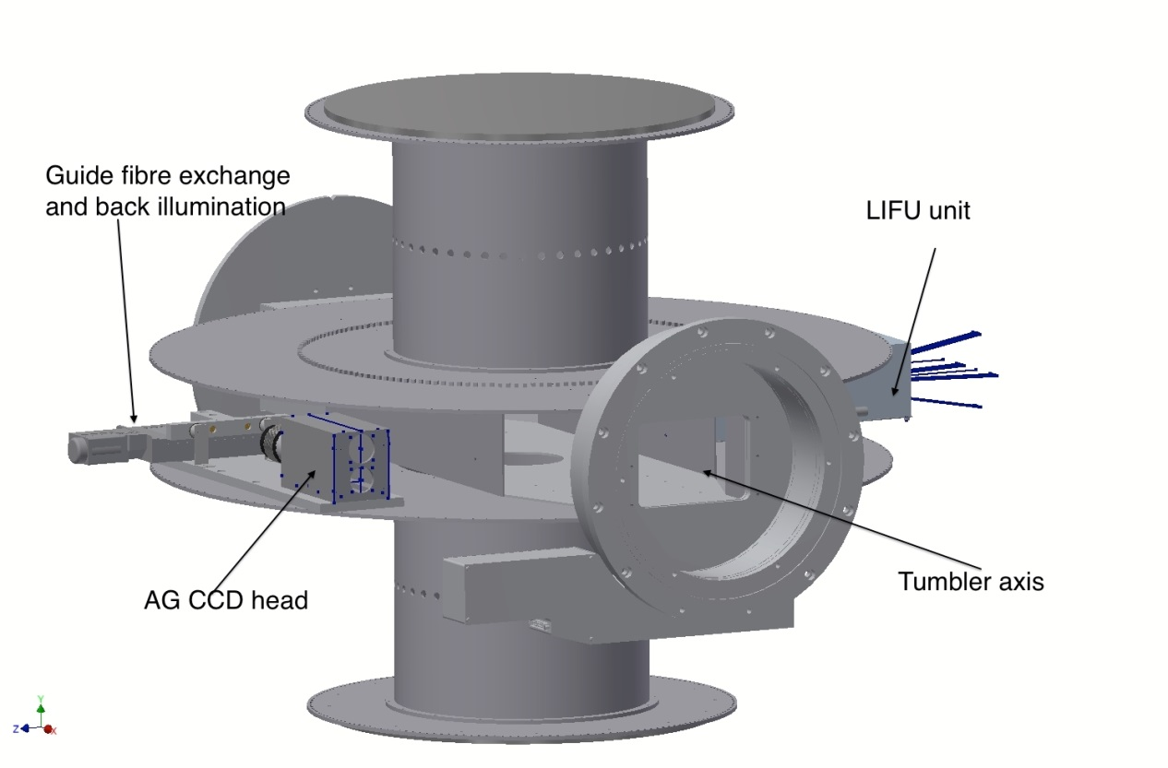Figure 1 Weave tumbler

The camera heads used with Weave have also been modified. They are electrically near identical to the standard head but have been repackaged to be much more compact. Space is an issue on the Weave positioner, particularly within the LIFU unit.
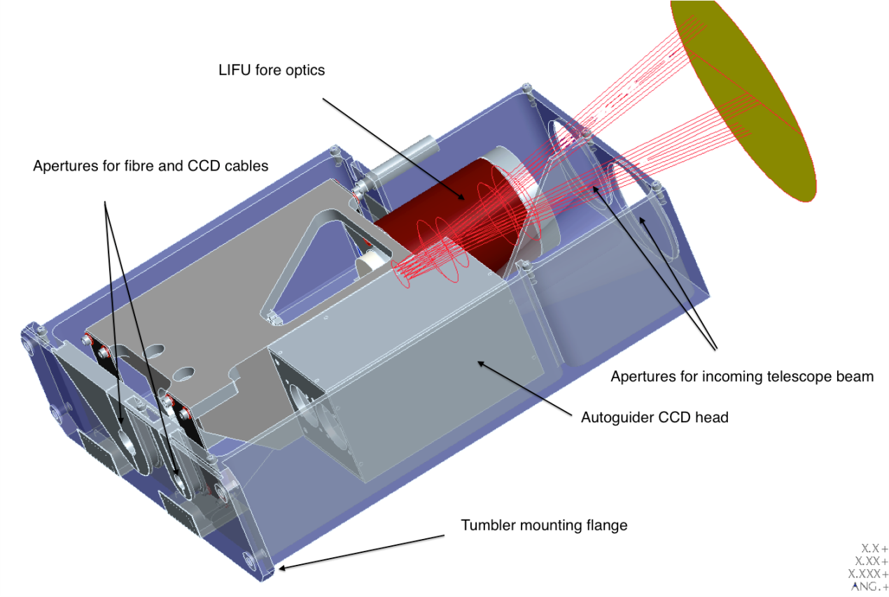
Figure 2 LIFU AG head
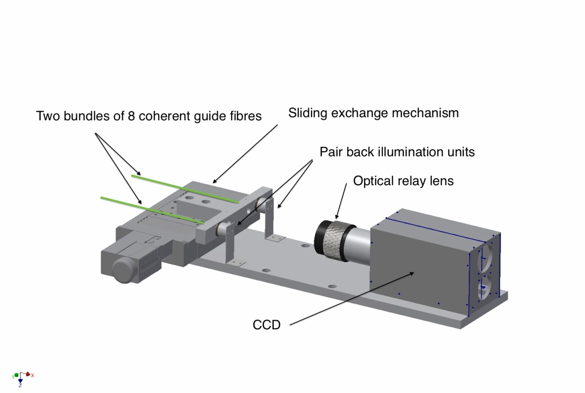
Figure 3 MOS AG head

The system works by reading out both of the AG camera heads as if it were a 2 CCD mosaic, despite the 2 CCDs being in different AG camera heads. The high level DAS software will then window the mosaic to readout just the AG camera required as defined by the position of the Weave tumbler. The system will then window around the selected guide star.

